Triangular-Region Generator

Definition
# Source: AI Source: Provided by: [Data Path: Persons Table -> ID Column: 1, Name_En Column: Motasem Essam] -> From: [ChatGPT] on [7/25/2026]
A Triangular-Region Generator is a plane-region generator that uses a filled triangular region as its generating figure to produce three-dimensional solids through rotation, translation, or other spatial movements.
The resulting solid depends on the triangle's shape, its position, and the movement applied to it.
Common generated solids include:
- Cone: Generated by rotating a right-triangular region around one of its perpendicular sides.
- Triangular Prism: Generated by translating a triangular region perpendicular to its plane.
- Oblique Triangular Prism: Generated by translating a triangular region in an oblique direction.
- Solids of Revolution: Generated by rotating a triangular region around an axis in or outside its plane.
Important distinction:
- A triangular region is a filled two-dimensional area. Its movement can generate a three-dimensional solid.
- A triangular boundary consists of three line segments. Its movement generates surfaces rather than a filled solid.

Geometric Representation
# Source: AI Source: Provided by: [Data Path: Persons Table -> ID Column: 1, Name_En Column: Motasem Essam] -> From: [ChatGPT] on [7/25/2026]
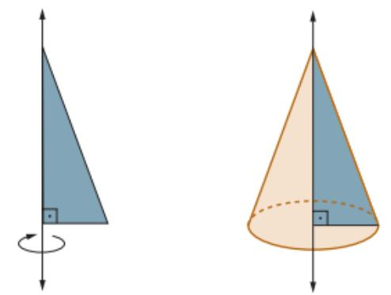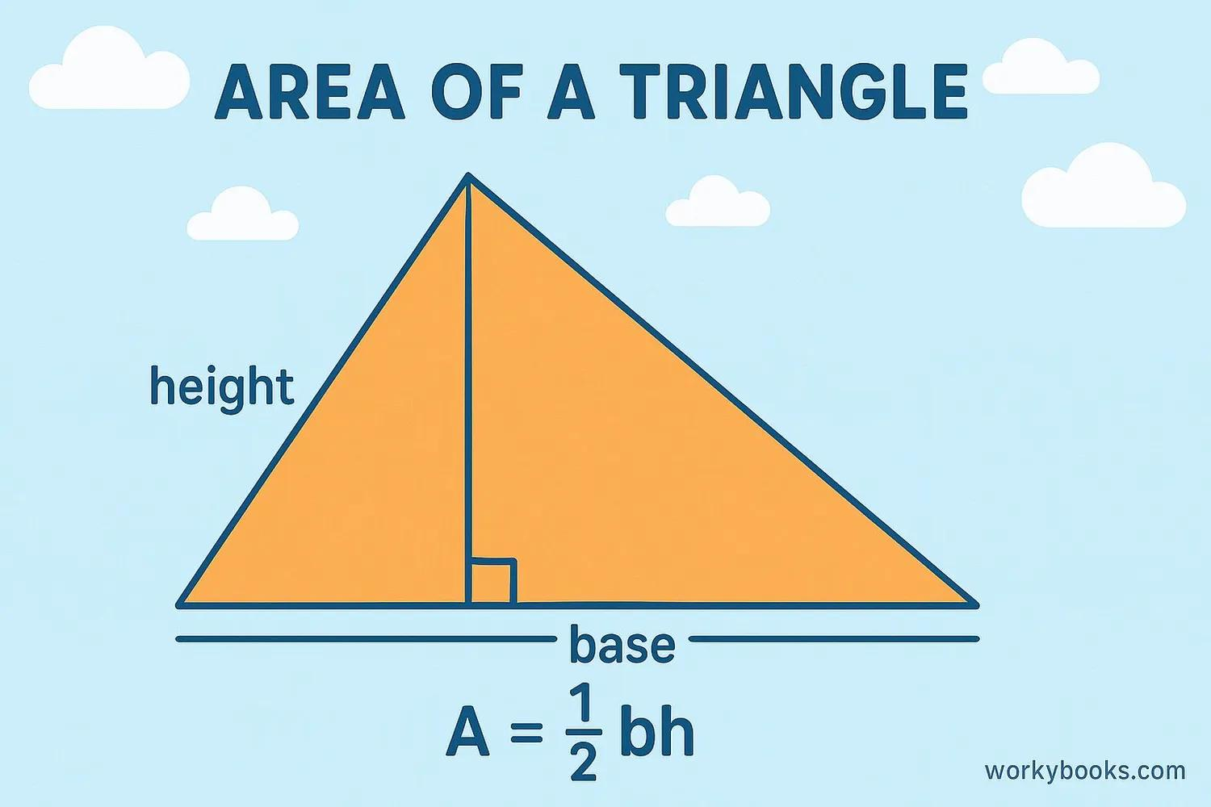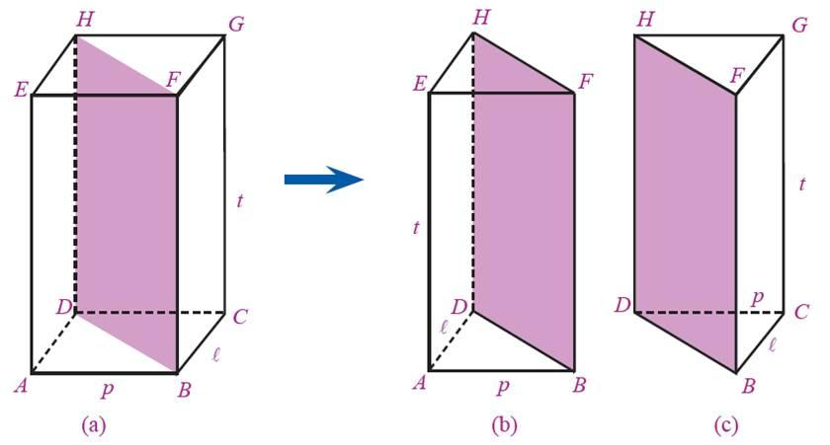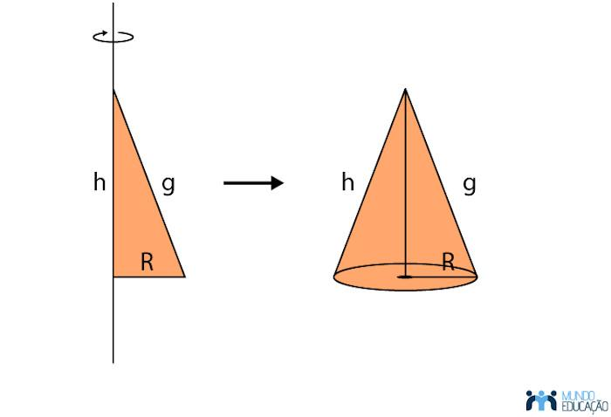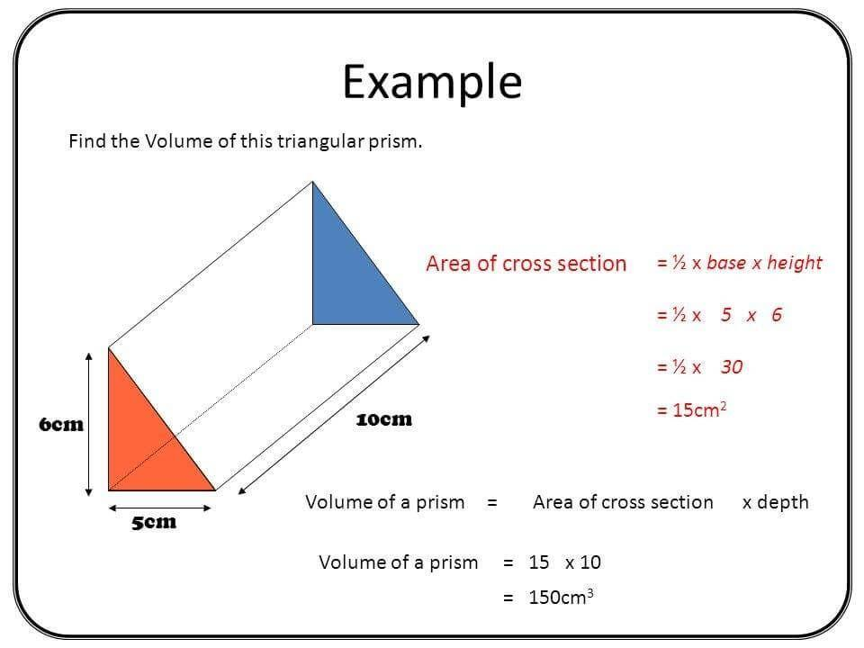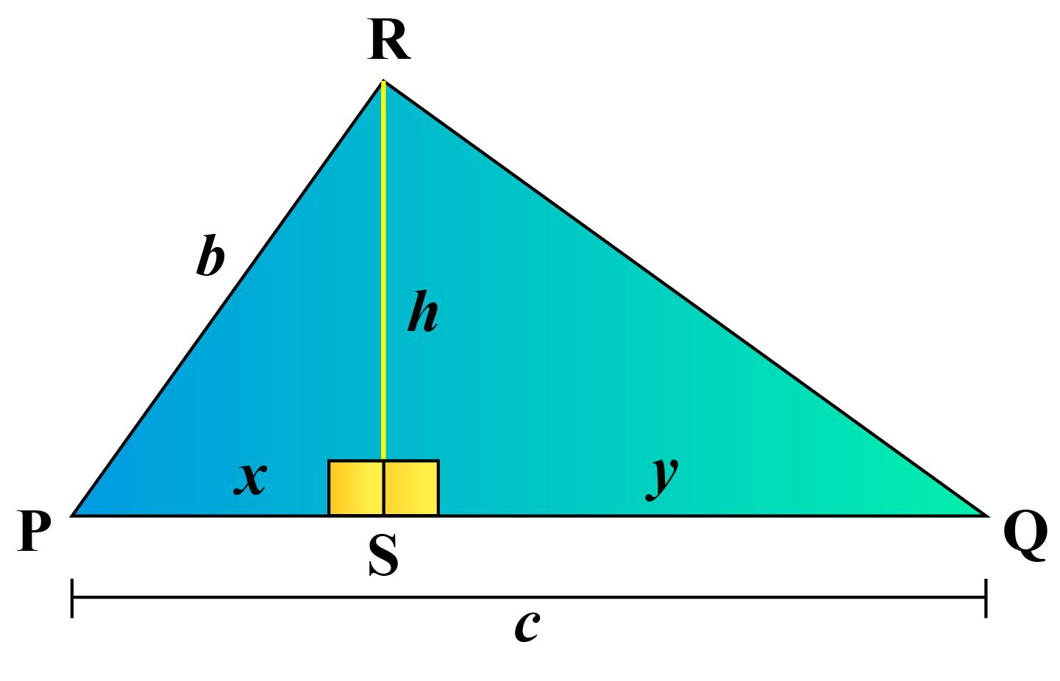

Geometric Structure
# Source: AI Source: Provided by: [Data Path: Persons Table -> ID Column: 1, Name_En Column: Motasem Essam] -> From: [ChatGPT] on [7/25/2026]
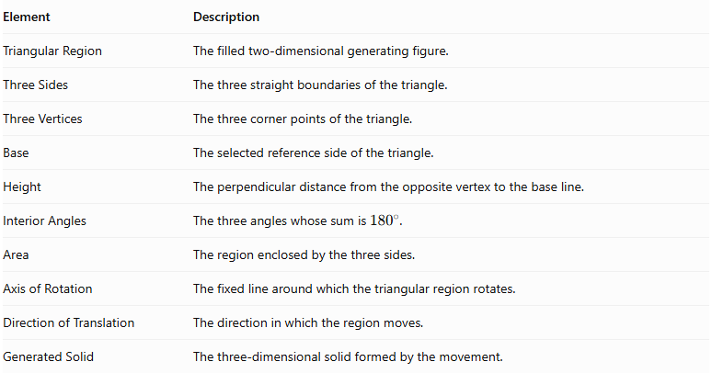
Element | Description
Triangular Region | The filled two-dimensional generating figure.
Three Sides | The three straight boundaries of the triangle.
Three Vertices | The three corner points of the triangle.
Base | The selected reference side of the triangle.
Height | The perpendicular distance from the opposite vertex to the base line.
Interior Angles | The three angles whose sum is ${180}^{∘}$.
Area | The region enclosed by the three sides.
Axis of Rotation | The fixed line around which the triangular region rotates.
Direction of Translation | The direction in which the region moves.
Generated Solid | The three-dimensional solid formed by the movement.

Types of Triangular-Region Generators According to Movement

Rotational Triangular-Region Generator
# Source: AI Source: Provided by: [Data Path: Persons Table -> ID Column: 1, Name_En Column: Motasem Essam] -> From: [ChatGPT] on [7/25/2026]
A triangular region rotates around a fixed axis to generate a solid of revolution.

A. Rotation Around One of the Perpendicular Sides of a Right Triangle
# Source: AI Source: Provided by: [Data Path: Persons Table -> ID Column: 1, Name_En Column: Motasem Essam] -> From: [ChatGPT] on [7/25/2026]
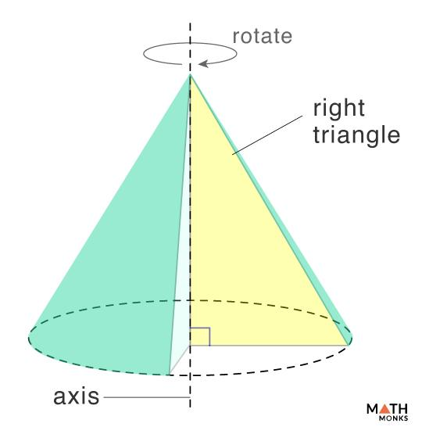
When a right-triangular region rotates around one of its perpendicular sides, it generates a Right Circular Cone.
- The side on the axis becomes the cone's height.
- The other perpendicular side becomes the cone's base radius.
- The hypotenuse generates the cone's lateral surface.
- The triangular region sweeps out the filled conical solid.

B. Rotation Around the Hypotenuse of a Right Triangle
# Source: AI Source: Provided by: [Data Path: Persons Table -> ID Column: 1, Name_En Column: Motasem Essam] -> From: [ChatGPT] on [7/25/2026]
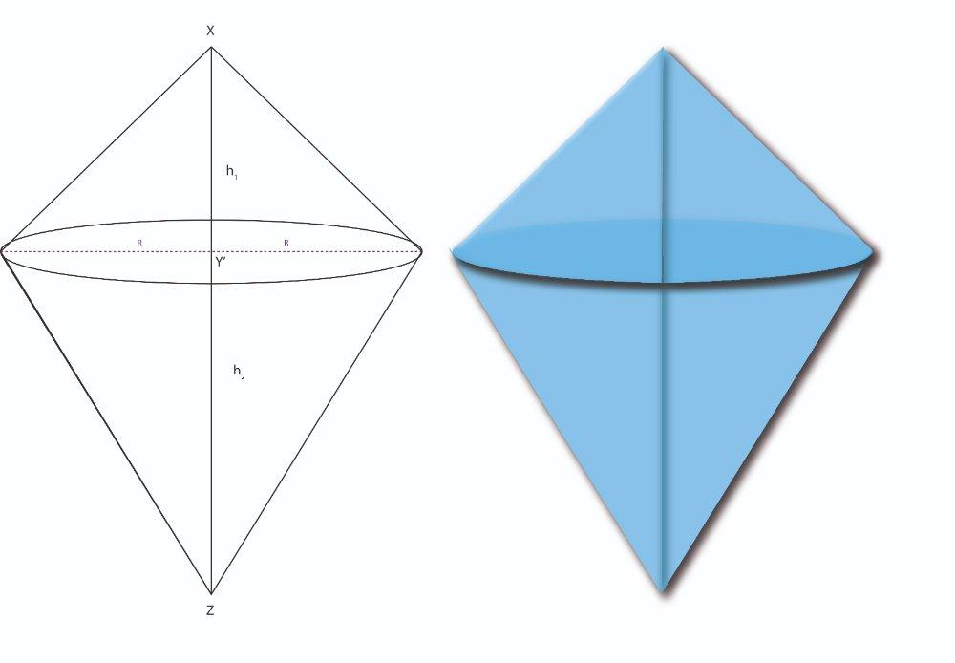
When a right-triangular region rotates around its hypotenuse, it generates a solid formed by two right circular cones joined at a common circular base.
- The hypotenuse becomes the common axis.
- The right-angle vertex traces a circular path.
- The two perpendicular sides generate the lateral surfaces of the two cones.
- The cones have a common base radius, but generally have different heights.
This is a double-cone solid (a bicone), not a single cone.

C. Rotation Around an External Axis
# Source: AI Source: Provided by: [Data Path: Persons Table -> ID Column: 1, Name_En Column: Motasem Essam] -> From: [ChatGPT] on [7/25/2026]
When a triangular region rotates around an external axis in its plane, the generated solid depends on the axis's position relative to the triangle.
For example, an axis parallel to one side and outside the triangle can produce a solid with a more complex cross-section, potentially containing a hollow or central region.

D. Rotation Around the Axis of Symmetry of an Isosceles Triangle
# Source: AI Source: Provided by: [Data Path: Persons Table -> ID Column: 1, Name_En Column: Motasem Essam] -> From: [ChatGPT] on [7/25/2026]
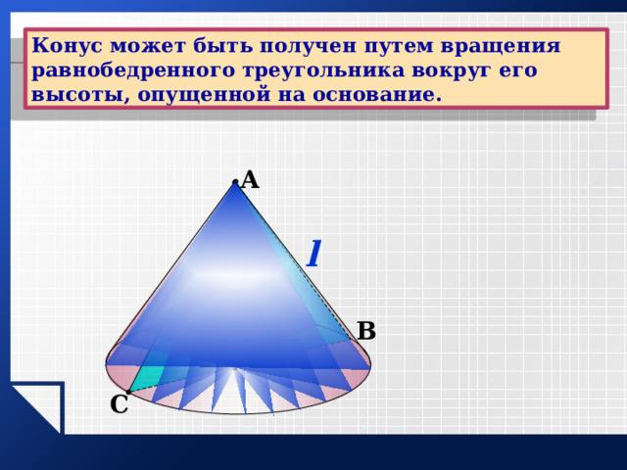
When an isosceles triangular region rotates around its altitude, it generates a Right Circular Cone.
- The altitude becomes the cone's height.
- Half the base becomes the cone's radius.
- The equal sides generate the cone's lateral surface.

Translational Triangular-Region Generator
# Source: AI Source: Provided by: [Data Path: Persons Table -> ID Column: 1, Name_En Column: Motasem Essam] -> From: [ChatGPT] on [7/25/2026]
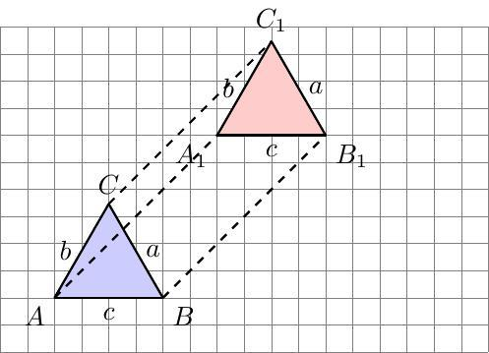
A triangular region moves along a straight direction without rotating.
A. Perpendicular Translation
When the triangular region moves perpendicularly to its plane, it generates a Right Triangular Prism.
- The original triangle forms one triangular base.
- The translated triangle forms the other triangular base.
- The connecting faces are rectangles.
B. Oblique Translation
When the triangular region moves in a direction oblique to its plane, it generates an Oblique Triangular Prism.
- The two triangular bases remain congruent and parallel.
- The lateral faces are parallelograms.
- The translation distance is not necessarily equal to the perpendicular height of the prism.

Combined Rotational and Translational Triangular-Region Generator
# Source: AI Source: Provided by: [Data Path: Persons Table -> ID Column: 1, Name_En Column: Motasem Essam] -> From: [ChatGPT] on [7/25/2026]
A triangular region can undergo rotation and translation simultaneously.
This movement generates a swept solid whose shape depends on the path, rotation axis, and orientation of the triangle. It may produce complex solids that are not necessarily standard cones or triangular prisms.

Types of Triangular-Region Generators According to Triangle Shape

Right-Triangular-Region Generator
# Source: AI Source: Provided by: [Data Path: Persons Table -> ID Column: 1, Name_En Column: Motasem Essam] -> From: [ChatGPT] on [7/25/2026]
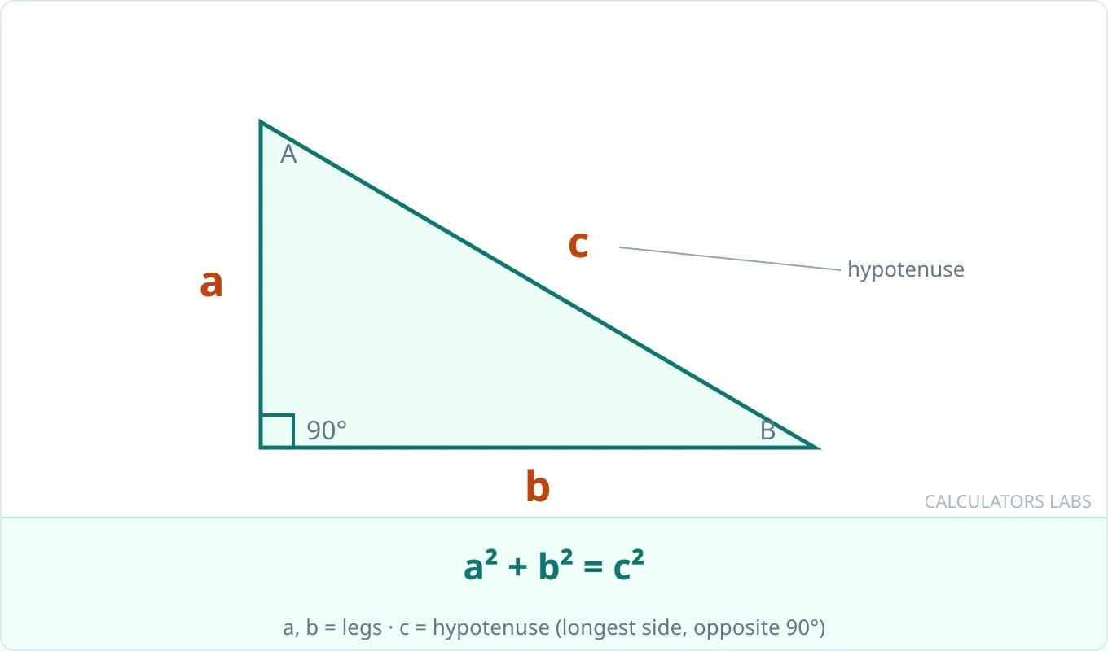
Uses a right-triangular region, which has one interior angle equal to ${90}^{∘}$.
Common generation:
- Rotation around either perpendicular side → Right Circular Cone.
- Rotation around the hypotenuse → Two cones joined at a common circular base.
- Perpendicular translation → Right Triangular Prism.

Equilateral-Triangular-Region Generator
# Source: AI Source: Provided by: [Data Path: Persons Table -> ID Column: 1, Name_En Column: Motasem Essam] -> From: [ChatGPT] on [7/25/2026]
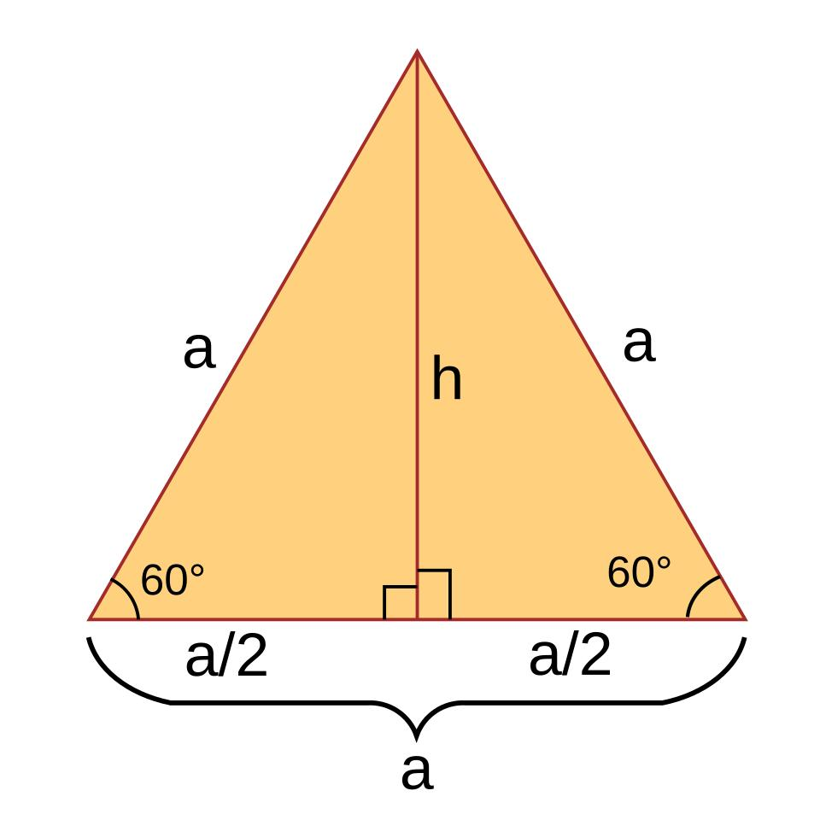
Uses an equilateral triangle, whose three sides and three interior angles are equal.
Common generation:
- Rotation around its altitude → Right Circular Cone.
- Perpendicular translation → Right Triangular Prism with equilateral triangular bases.

Isosceles-Triangular-Region Generator
# Source: AI Source: Provided by: [Data Path: Persons Table -> ID Column: 1, Name_En Column: Motasem Essam] -> From: [ChatGPT] on [7/25/2026]
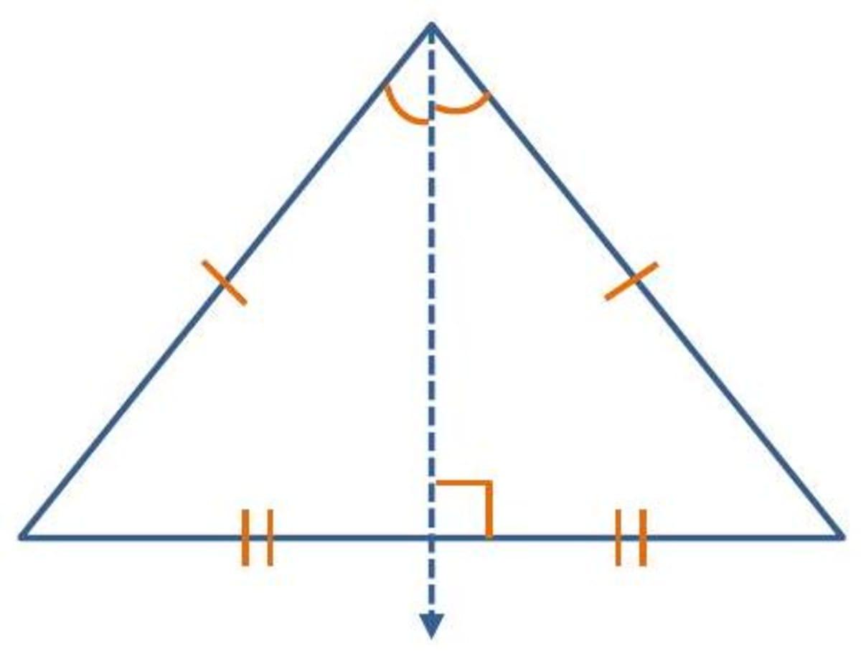
Uses an isosceles triangle, which has two equal sides and two equal base angles.
Common generation:
- Rotation around its altitude → Right Circular Cone.
- Perpendicular translation → Right Triangular Prism.

Scalene-Triangular-Region Generator
# Source: AI Source: Provided by: [Data Path: Persons Table -> ID Column: 1, Name_En Column: Motasem Essam] -> From: [ChatGPT] on [7/25/2026]
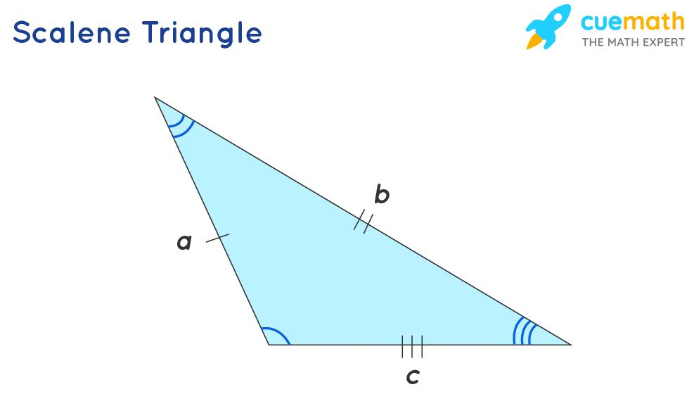
Uses a scalene triangle, whose three sides have different lengths.
Common generation:
- Rotation around one of its sides → A solid of revolution that may consist of two cones joined at a common base when the opposite vertex projects onto the interior of that side.
- Perpendicular translation → Right Triangular Prism.
Classification note: Triangle shape and movement are independent classification criteria. For example, a right triangle can be used in either rotational or translational generation.

Mathematical Representation
# Source: AI Source: Provided by: [Data Path: Persons Table -> ID Column: 1, Name_En Column: Motasem Essam] -> From: [ChatGPT] on [7/25/2026]
Let a triangular region have:
- Base $b$
- Perpendicular height $h$
- Side lengths $a,b,c$
- Area $A$

Area of a Triangular Region
# Source: AI Source: Provided by: [Data Path: Persons Table -> ID Column: 1, Name_En Column: Motasem Essam] -> From: [ChatGPT] on [7/25/2026]
$$A=\frac{1}{2}bh$$
The perimeter is:
$$P=a+b+c$$
For a right triangle with perpendicular sides $r$ and $H$:
$$c=\sqrt{r^{2}+H^{2}}$$
Where $c$ is the hypotenuse.

Right Circular Cone Generated by Rotation
# Source: AI Source: Provided by: [Data Path: Persons Table -> ID Column: 1, Name_En Column: Motasem Essam] -> From: [ChatGPT] on [7/25/2026]
When a right-triangular region rotates around one of its perpendicular sides:
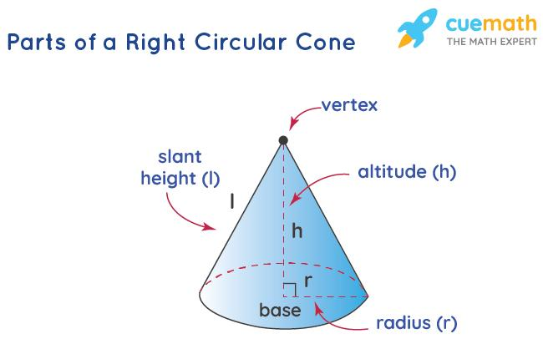
Let:
- $r$ = base radius.
- $H$ = cone height.
- $l$ = slant height.
The slant height is:
$$l=\sqrt{r^{2}+H^{2}}$$
Base area:
$$A_{b}=πr^{2}$$
Lateral surface area:
$$A_{l}=πrl$$
Total surface area:
$$A_{t}=πr^{2}+πrl$$
Volume:
$$V=\frac{1}{3}πr^{2}H$$

Double Cone Generated by Rotation Around the Hypotenuse
# Source: AI Source: Provided by: [Data Path: Persons Table -> ID Column: 1, Name_En Column: Motasem Essam] -> From: [ChatGPT] on [7/25/2026]
When a right-triangular region rotates around its hypotenuse, it generates two cones sharing a common circular base.
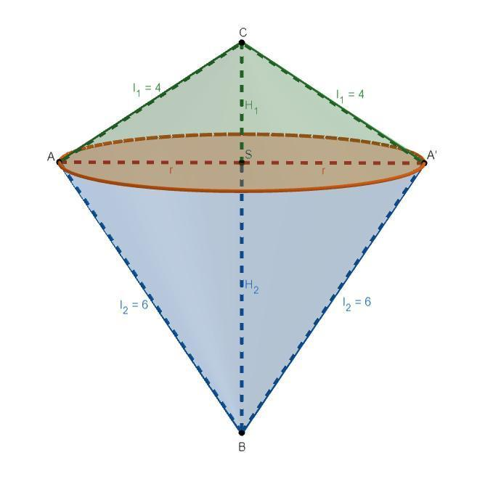
Let:
- $m,n$ = perpendicular sides of the triangle.
- $c$ = hypotenuse.
- $r$ = common radius of the cones.
The common radius equals the altitude drawn from the right-angle vertex to the hypotenuse:
$$r=\frac{mn}{c}$$
The total volume is:
$$V=\frac{1}{3}πr^{2}c$$
The total lateral surface area is:
$$A_{l}=πr(m+n)$$
The two cones share an internal base, so that circular base is not included in the external surface area.

Triangular Prism Generated by Translation
# Source: AI Source: Provided by: [Data Path: Persons Table -> ID Column: 1, Name_En Column: Motasem Essam] -> From: [ChatGPT] on [7/25/2026]
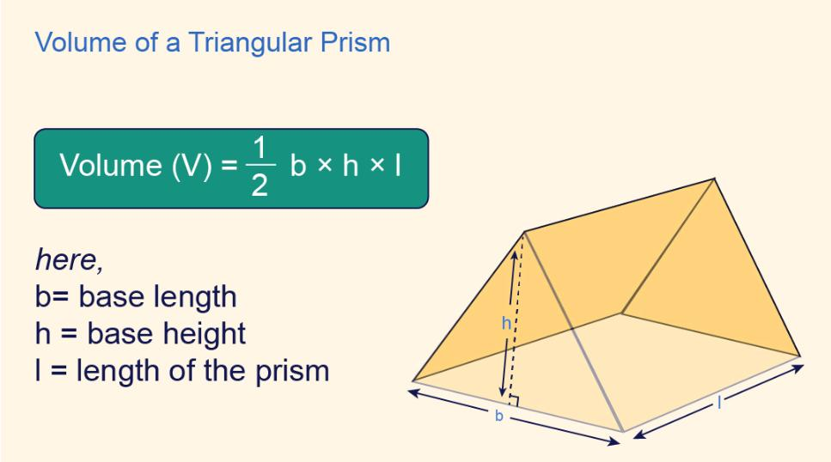
Let:
- $A$ = area of the triangular base.
- $H$ = perpendicular distance between the two triangular bases.
Volume:
$$V=AH$$
Using the triangle area formula:
$$V=\frac{1}{2}bhH$$
For a right triangular prism, where the triangular base has perpendicular sides $m,n$:
$$V=\frac{1}{2}mnH$$
For a right triangular prism, its total surface area is:
$$A_{t}=2A+PH$$
Where $P$ is the perimeter of the triangular base.
For an oblique triangular prism, the lateral surface area depends on the lengths and orientations of its parallelogram faces.

Mathematical Properties
# Source: AI Source: Provided by: [Data Path: Persons Table -> ID Column: 1, Name_En Column: Motasem Essam] -> From: [ChatGPT] on [7/25/2026]
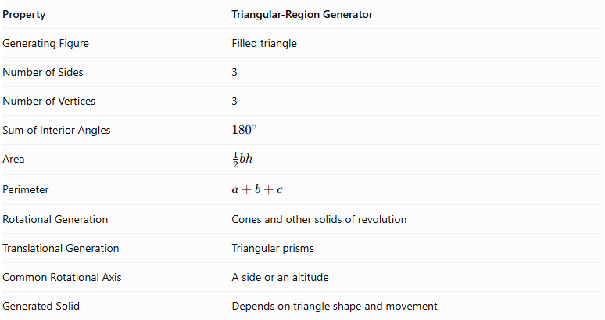
Property | Triangular-Region Generator
Generating Figure | Filled triangle
Number of Sides | 3
Number of Vertices | 3
Sum of Interior Angles | $${180}^{∘}$$
Area | $$\frac{1}{2}bh$$
Perimeter | $$a+b+c$$
Rotational Generation | Cones and other solids of revolution
Translational Generation | Triangular prisms
Common Rotational Axis | A side or an altitude
Generated Solid | Depends on triangle shape and movement

Generated Surfaces and Solids

Right Circular Cone
# Source: AI Source: Provided by: [Data Path: Persons Table -> ID Column: 1, Name_En Column: Motasem Essam] -> From: [ChatGPT] on [7/25/2026]
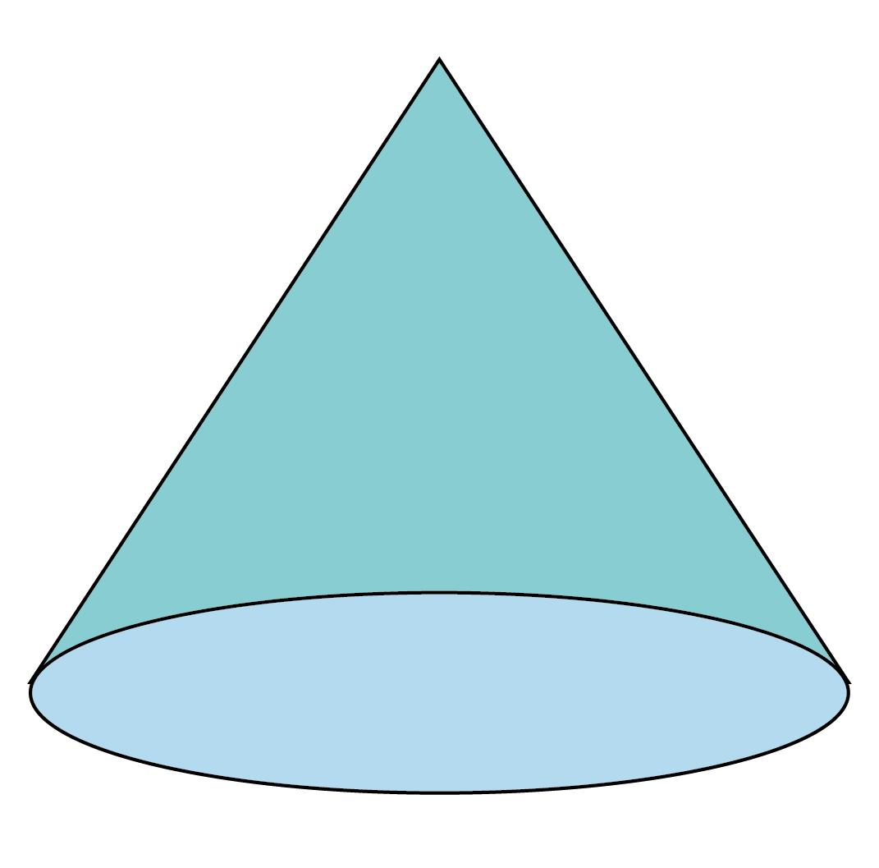
Generated by rotating a right-triangular region around one of its perpendicular sides, or an isosceles triangular region around its altitude.

Double Cone (Bicone)
# Source: AI Source: Provided by: [Data Path: Persons Table -> ID Column: 1, Name_En Column: Motasem Essam] -> From: [ChatGPT] on [7/25/2026]
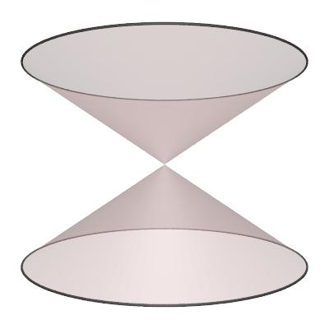
Generated by rotating a right-triangular region around its hypotenuse.

Right Triangular Prism
# Source: AI Source: Provided by: [Data Path: Persons Table -> ID Column: 1, Name_En Column: Motasem Essam] -> From: [ChatGPT] on [7/25/2026]
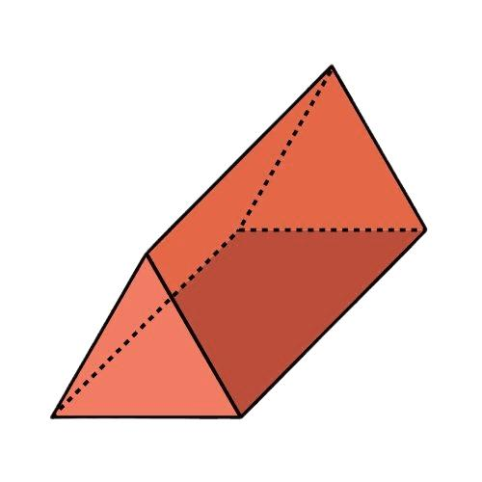
Generated by translating a triangular region perpendicularly to its plane.

Oblique Triangular Prism
# Source: AI Source: Provided by: [Data Path: Persons Table -> ID Column: 1, Name_En Column: Motasem Essam] -> From: [ChatGPT] on [7/25/2026]
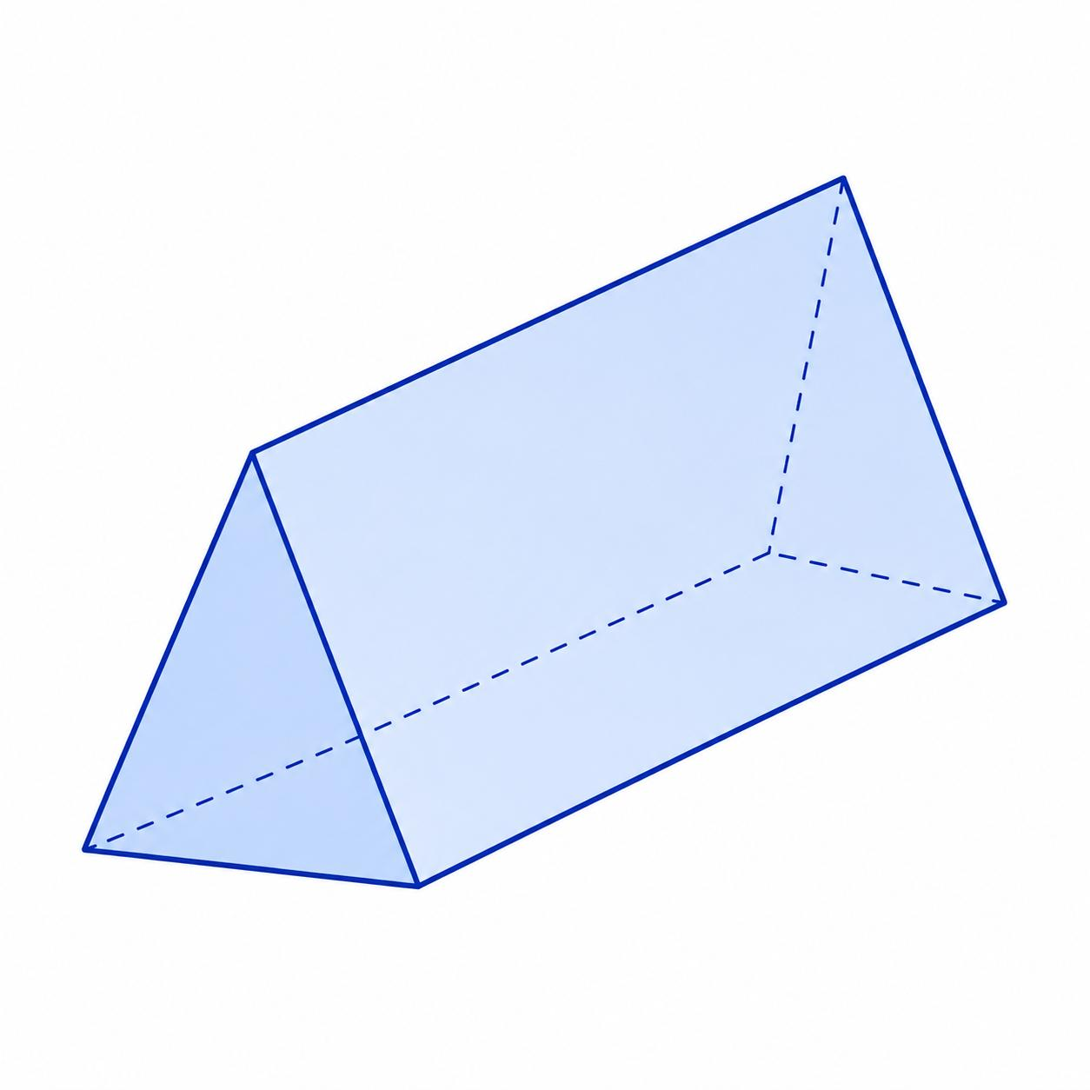
Generated by translating a triangular region in an oblique direction relative to its plane.

Applications
# Source: AI Source: Provided by: [Data Path: Persons Table -> ID Column: 1, Name_En Column: Motasem Essam] -> From: [ChatGPT] on [7/25/2026]
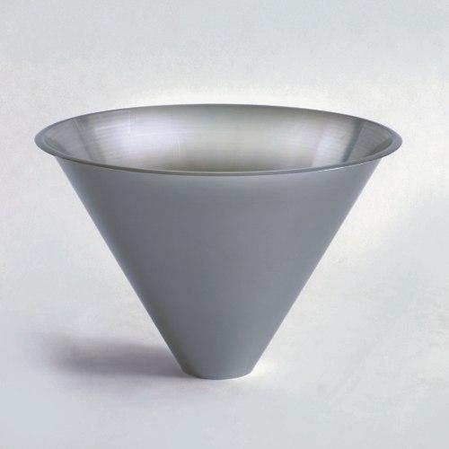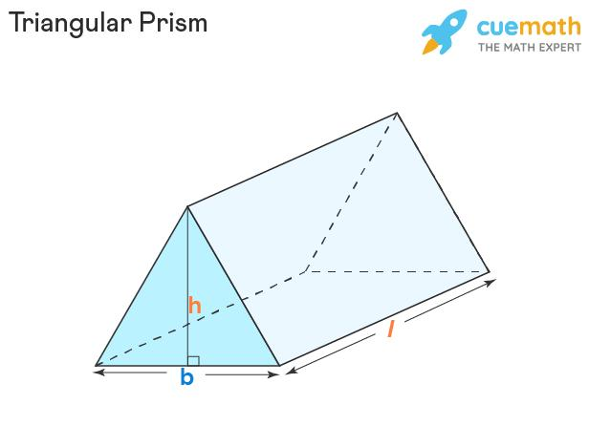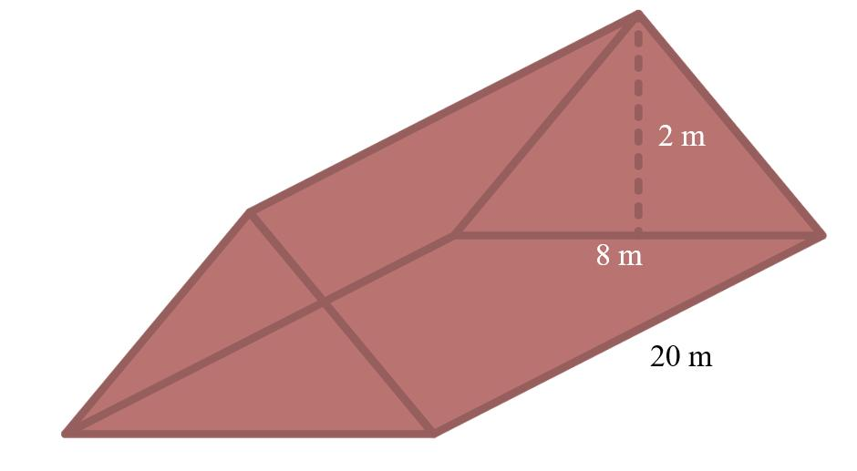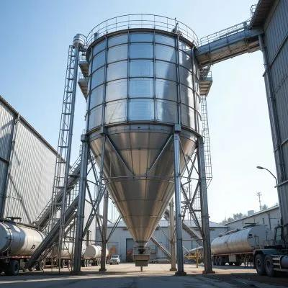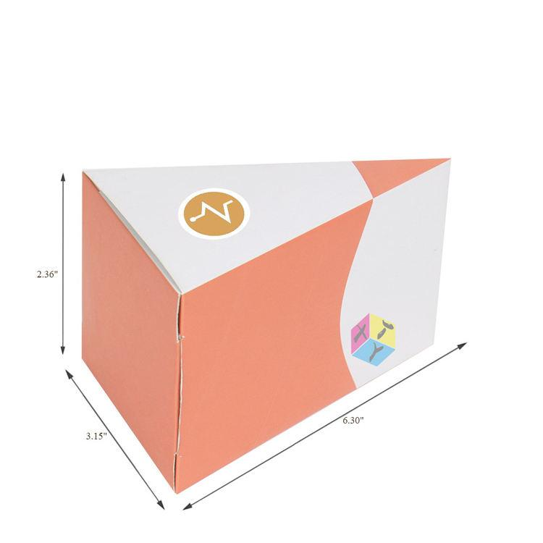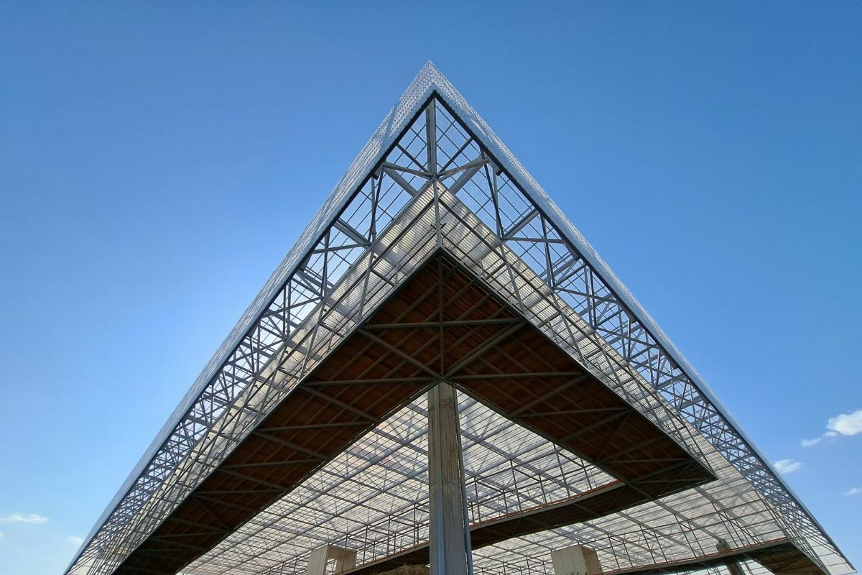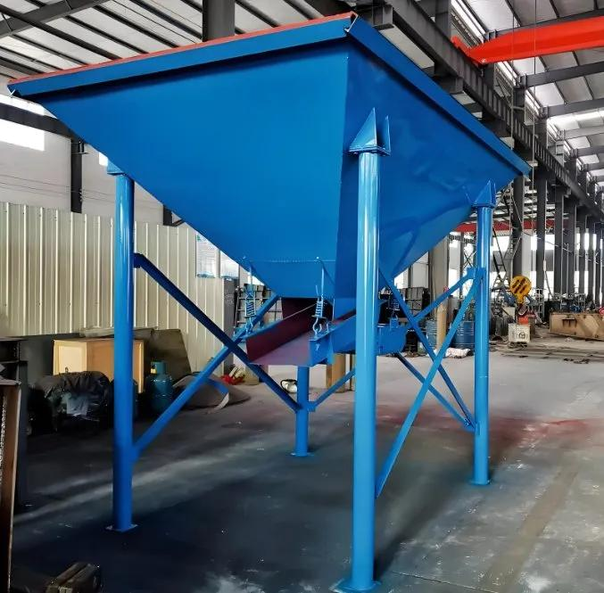
- Conical Containers: Funnels, hoppers, and conical storage structures.
- Architectural Structures: Triangular-prism roof sections and structural components.
- Packaging: Triangular-prism packages and containers.
- Engineering: Conical components and triangular-prism structural elements.
- Geometric Modeling: Constructing three-dimensional shapes from triangular cross-sections.

Comparison with Other Plane-Region Generators
# Source: AI Source: Provided by: [Data Path: Persons Table -> ID Column: 1, Name_En Column: Motasem Essam] -> From: [ChatGPT] on [7/25/2026]
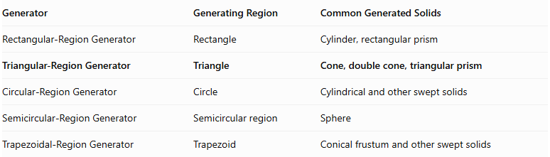
Generator | Generating Region | Common Generated Solids
Rectangular-Region Generator | Rectangle | Cylinder, rectangular prism
Triangular-Region Generator | Triangle | Cone, double cone, triangular prism
Circular-Region Generator | Circle | Cylindrical and other swept solids
Semicircular-Region Generator | Semicircular region | Sphere
Trapezoidal-Region Generator | Trapezoid | Conical frustum and other swept solids

Main Classification
# Source: AI Source: Provided by: [Data Path: Persons Table -> ID Column: 1, Name_En Column: Motasem Essam] -> From: [ChatGPT] on [7/25/2026]
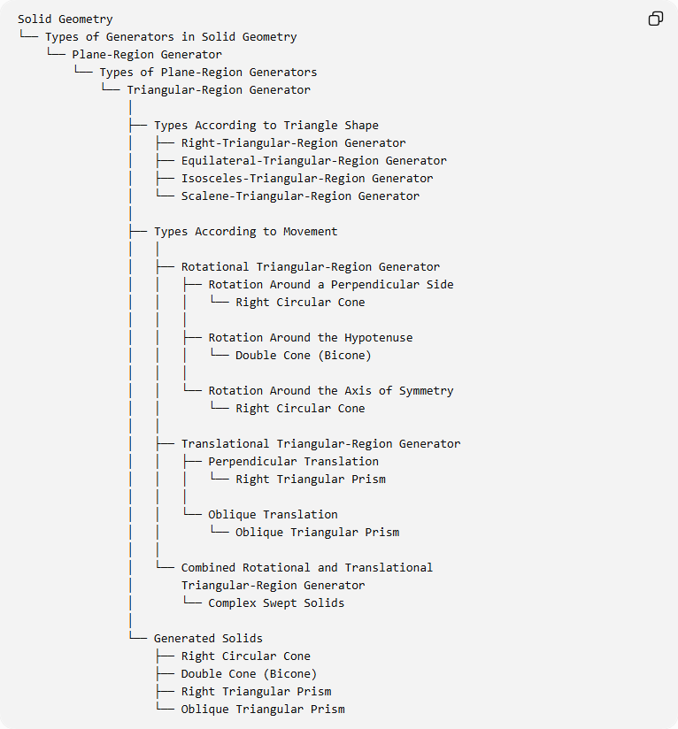
Solid Geometry
└── Types of Generators in Solid Geometry
└── Plane-Region Generator
└── Types of Plane-Region Generators
└── Triangular-Region Generator
│
├── Types According to Triangle Shape
│ ├── Right-Triangular-Region Generator
│ ├── Equilateral-Triangular-Region Generator
│ ├── Isosceles-Triangular-Region Generator
│ └── Scalene-Triangular-Region Generator
│
├── Types According to Movement
│ │
│ ├── Rotational Triangular-Region Generator
│ │ ├── Rotation Around a Perpendicular Side
│ │ │ └── Right Circular Cone
│ │ │
│ │ ├── Rotation Around the Hypotenuse
│ │ │ └── Double Cone (Bicone)
│ │ │
│ │ └── Rotation Around the Axis of Symmetry
│ │ └── Right Circular Cone
│ │
│ ├── Translational Triangular-Region Generator
│ │ ├── Perpendicular Translation
│ │ │ └── Right Triangular Prism
│ │ │
│ │ └── Oblique Translation
│ │ └── Oblique Triangular Prism
│ │
│ └── Combined Rotational and Translational
│ Triangular-Region Generator
│ └── Complex Swept Solids
│
└── Generated Solids
├── Right Circular Cone
├── Double Cone (Bicone)
├── Right Triangular Prism
└── Oblique Triangular Prism

Key Points
# Source: AI Source: Provided by: [Data Path: Persons Table -> ID Column: 1, Name_En Column: Motasem Essam] -> From: [ChatGPT] on [7/25/2026]
- A triangular-region generator uses a filled triangle to produce three-dimensional solids.
- Rotating a right triangle around one of its perpendicular sides generates a right circular cone.
- Rotating a right triangle around its hypotenuse generates two cones sharing a common circular base.
- Rotating an isosceles triangle around its altitude generates a right circular cone.
- Perpendicular translation generates a right triangular prism.
- Oblique translation generates an oblique triangular prism.
- The generated solid depends on both the triangle's geometry and its movement.

Conclusion
# Source: AI Source: Provided by: [Data Path: Persons Table -> ID Column: 1, Name_En Column: Motasem Essam] -> From: [ChatGPT] on [7/25/2026]
The Triangular-Region Generator is an important plane-region generator in solid geometry. It produces conical solids through rotation and triangular prisms through translation. Its classification depends on the shape of the generating triangle and the movement applied to it.

